Ethan Wieland attends State Officer Meeting
Ethan Wieland, the Section 5 President from the Princeville FFA Chapter attended the Illinois Association FFA July State Officer Meeting. The three-day meeting was held at the Northfield Inn and Conference Center in Springfield, Illinois on July 11-13, 2012. The Illinois Association FFA State Officer Team consists of thirty members: five Major State Officers and twenty-five Section Presidents from all across the State. At this meeting, the 2012-2012 State Officer Team set goals and expectations for the coming year’s activities and learned about the opportunities and responsibilities of their duties as a state officer. They also learned their responsibilities during Chapter Visits and Leadership Training School (team and leadership building workshops) in the fall. This meeting prepared these leaders for their year of service to the Illinois Association FFA. The FFA makes a positive difference in the lives of members by developing their potential for premier leadership, personal growth, and career success through agricultural education.

Section 5 Vo-Ag Fair 2012
Section 5's annual Vocational-Agriculture Fair was held on July 20, 2012 at the Marshall-Putnam Fairgrounds in Henry, Illinois. We had nine schools represented. The students exhibited poultry, horses, hogs, horticulture arrangements, sheep, beef, rabbits, dairy, goats, and mechanics projects. It was really neat to see all the hard effort that the students put in to raising these animals come out on display. It was a successful day and great learning experience for all. And remember, Agriculture is more than food, feed, and fuel. It is the foundation of our future.

FFA Leadership Camp
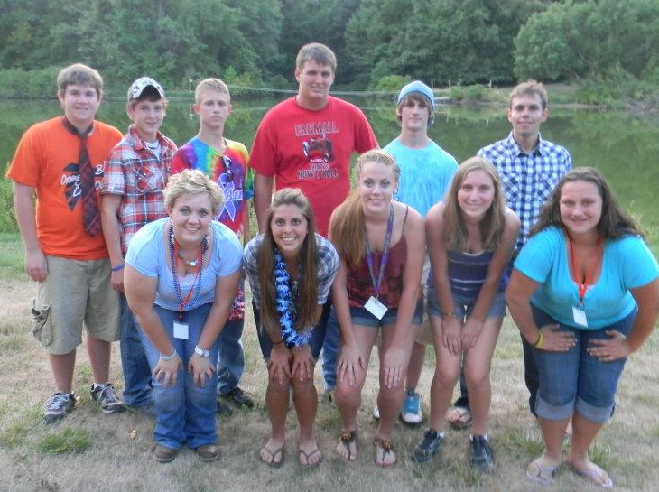
On July 24, 2012, Section 5's President, Ethan Wieland arrived at the 4-H Memorial campgrounds in Monticello, Illinois for a day of preparation for Leadership camp. The next day, we had eight other students from four schools come join in on the fun and learning experience. Karl Christ represented the Elmwood Chapter. Samantha Bessler and Jim Crank came from Midland FFA. Mikaela Wieland and Tessa Cowser were the leaders from Princeville. Putnam County brought Jake Rolando, Brandon Sanders, and Megan Wink. The members were split up into many groups and learned team building activities, how to successfully lead a chapter, and many new ideas to bring back to their chapter. Along with the learning, teh members also enjoyed a fun-filled week of games and activities. After a great week, everyone sadly had to say goodbye to their new friends and travel back home on Saturday, July 28th. I think everyone that attended would encourage more members to come next year and join in on the great experience. Agriculture is more than food, feed, and fuel. It is the foundation of our future.
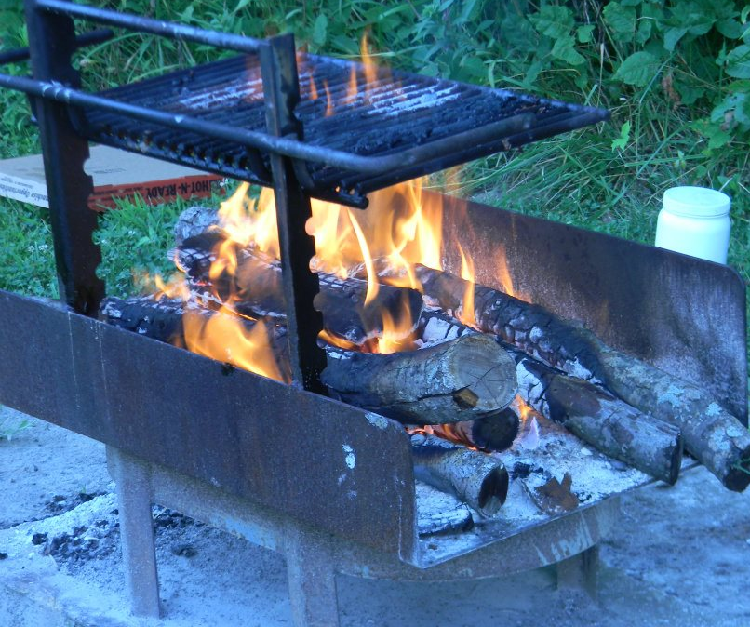
Section 5 Officer Retreat
On Sunday, July 29th, the Section 5 Officers met at the Jubilee campgrounds for a retreat and planning session for the 2012-2013 FFA year. When we arrived, we grilled hamburgers and corn on the cob for dinner. Then we discussed our plans for the year while enjoying some delicious apple dessert. It was a very beneficial meeting and e got a lot done. After our meeting, we enjoyed playing some team building games and camping out. In the morning we had a delicious breakfast before we went home. It was a successful retreat and we are looking forward to a great year! Agriculture is more than food, feed, and fuel. It is the foundation of our future.

