**November 2012**

**Volume 1, Issue 5**

Blue & Gold Journal

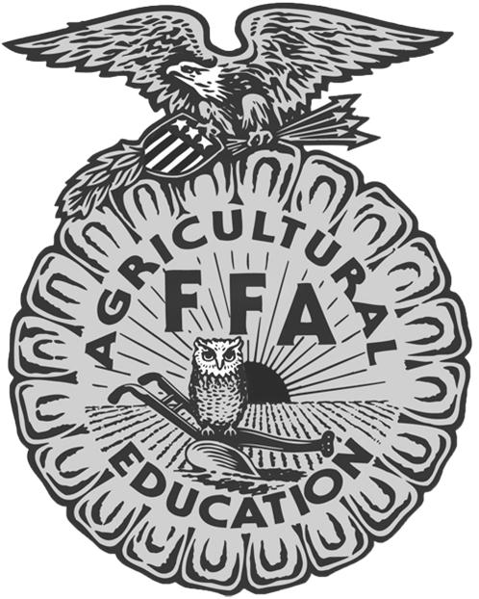

Mikaela Wieland

Section 5 Reporter

309.635.2496

mikaela.wieland@gmail.com

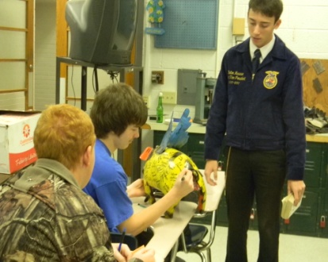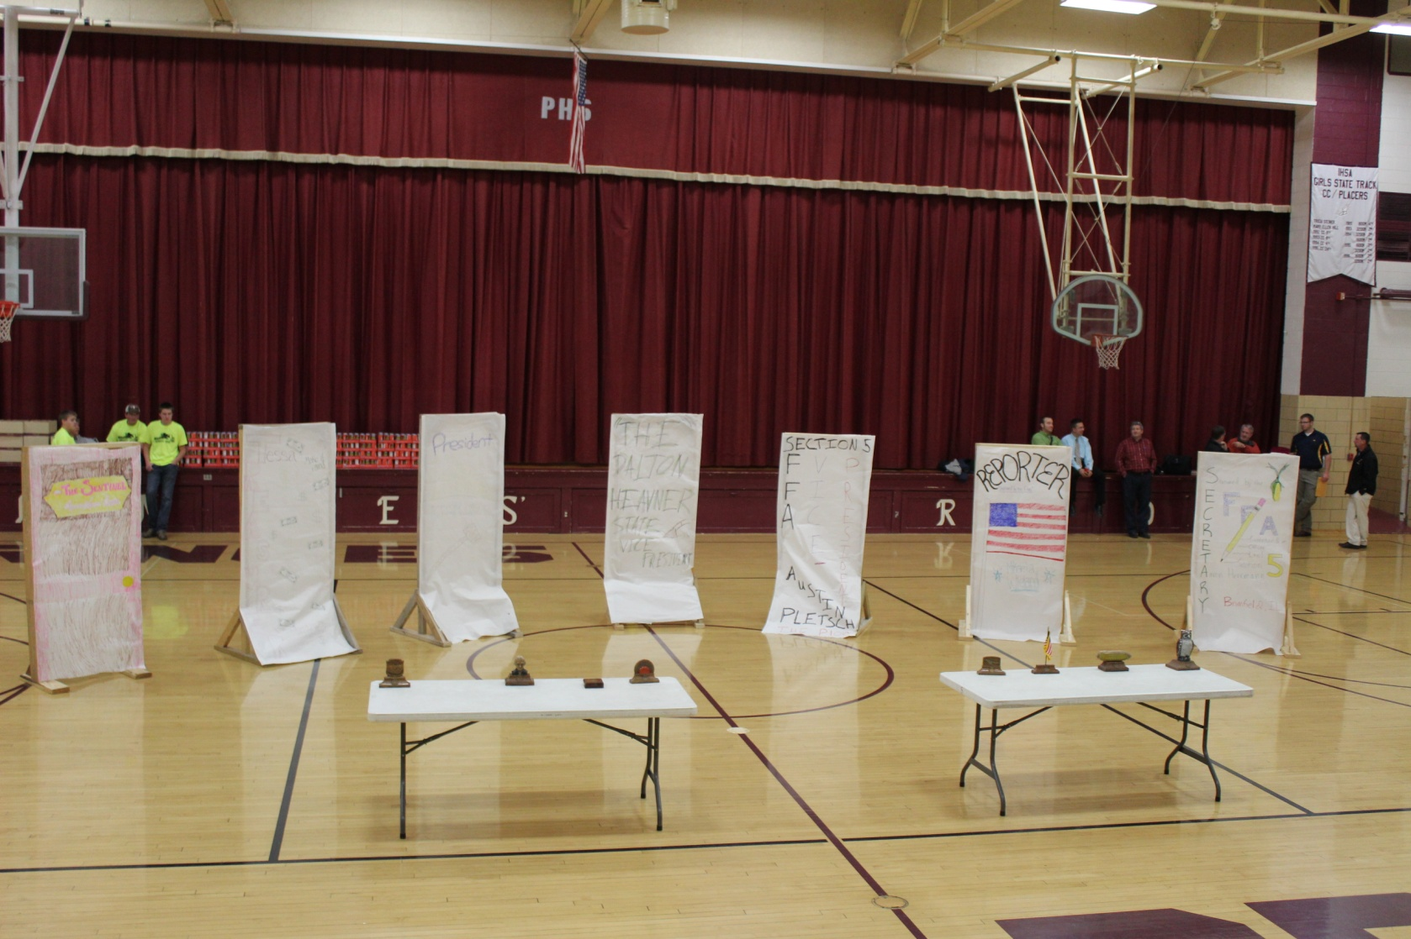

It’s hard to explain to someone. Wait, you’re ordering 120 pulled pork sandwiches for what? That’s right. It’s for Leadership Training School. It is designed to introduce new members to what FFA is all about and the opportunities they can have through FFA and to discover how they can become great leaders. We also use it as an opportunity for the section officers and chapter officers to meet and discuss the duties of their leadership positions. This year, Section 5 LTS was held on Wednesday November 7th at Princeville High School. Registration started at 4:30 and we kicked off the evening with an “unofficial” official dress demonstration. The section officers dressed up in their official dress, but wore it inappropriately, to demonstrate what NOT to wear. After the demonstration, we had an unforgettable opening ceremony! And since we were all hungry, we headed down to the cafeteria to enjoy those pulled pork sandwiches to get the evening off to a good start. Once everyone was satisfied, we all headed back up to the gym to help out those in need, whose food doesn’t come as easily. We wanted to help out this year at LTS and we packed food kits to take to those in need of food this holiday season. This showed everyone that helping others is a big part of FFA and being a good leader. After this, we split into groups of officers and Greenhand FFA members to learn some more about being a leader. Our State Vice-President, Dalton Heavner also assisted us on this night of LTS, and after our small groups, it was time for him to give a keynote speech. He talked to the whole group about his famous pig and then we ended the night with closing ceremonies. And that’s how Section 5 explains their Leadership Training School.

***Individual Highlights:***

Snapshots from LTS….2

November CDE’s……..3

Upcoming Events…….4

Dalton Heavner…….....5

Contact Us………….....6

***Special Interest Articles:***

* Section 5 LTS
* Chapter Visits
* Getting to Know “The” Dalton Heavner

C:\Users\Brian\AppData\Local\Microsoft\Windows\Temporary Internet Files\Content.IE5\NVS9N8BE\MC900389884[1].wmf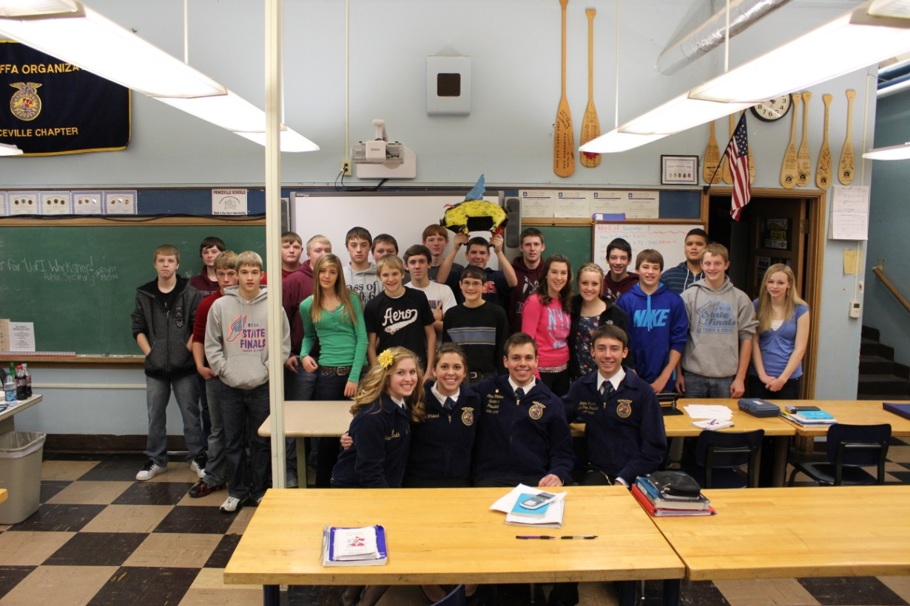

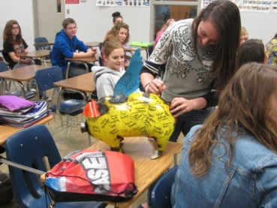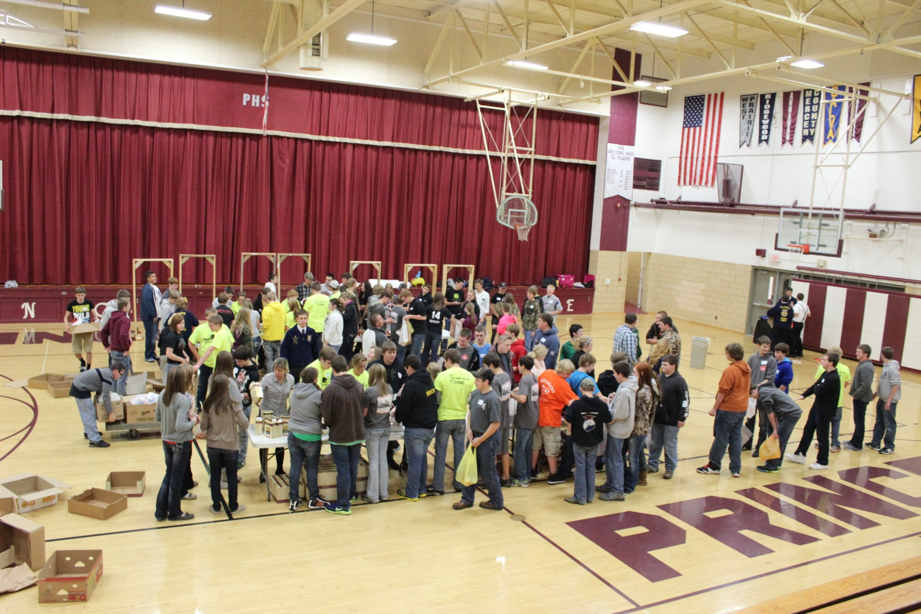

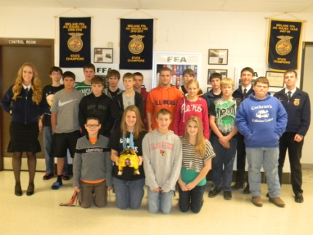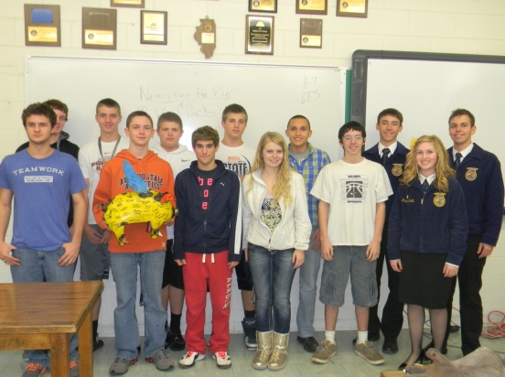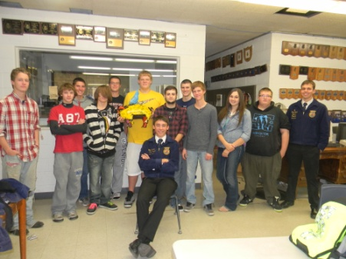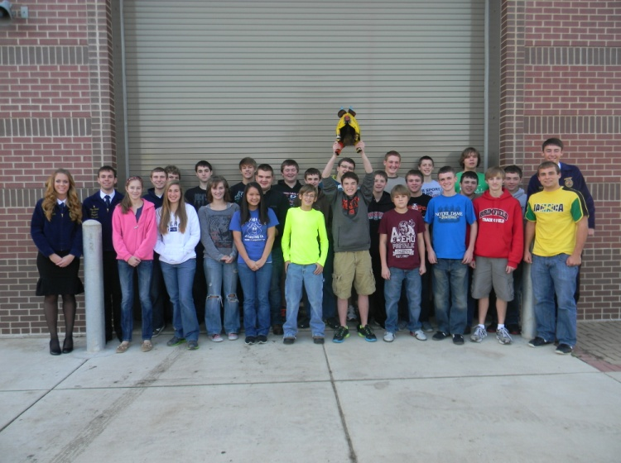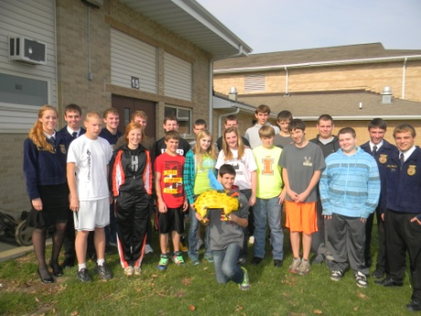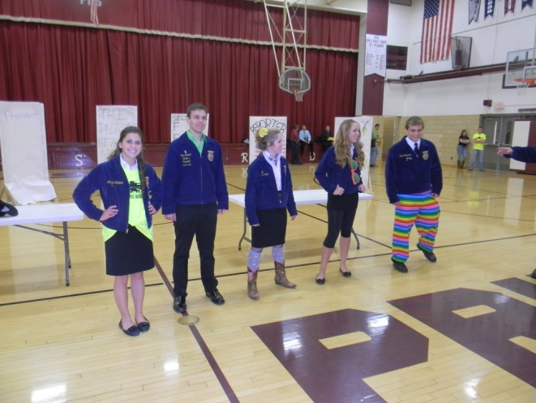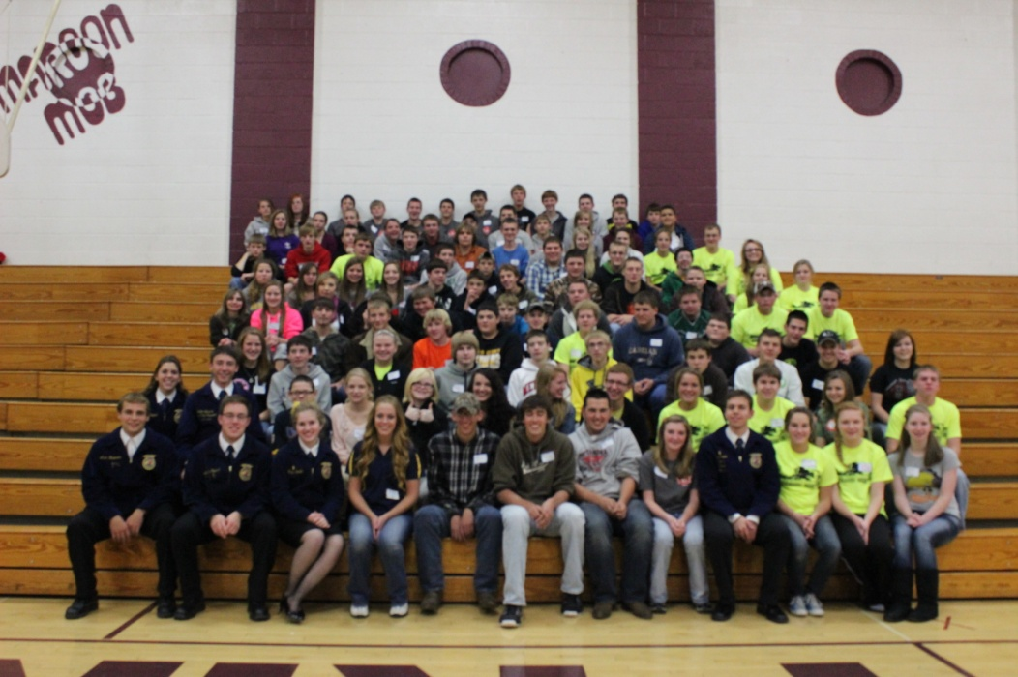

**Above: Midland Ag Class**

**Below: Leadership Training School**

**Above: The Elmwood Ag class.**

**Above: Packing Food Kits at LTS**

**Left: The Roanoke-Benson Ag Class**

**Below: Brimfield Intro to Ag class**

**Left: The Fieldcrest Ag Class during Chapter Visits**

**Above: “Unofficial” Official Dress at LTS**

**Above: The Princeville FFA Intro to Ag Class & Metamora Student signing “the pig”**

## **Food Science**

C:\Program Files (x86)\Microsoft Office\MEDIA\CAGCAT10\j0212661.wmf

The Food Science CDE for Section 5 was held on November 1st. Midland High School hosted the event and we had 6 chapters participating. There were four members on each team. Midland FFA won the event followed by Brimfield. Metamora came in 3rd place and Putnam County was the 4th place team. Eureka took 5th place and Elmwood was in sixth place. **Bobbi Toepper** from Midland was the top individual. **Alan Zimmerman** from Eureka was second. Midland had the next three individuals with **Dylan Herridge** in third, **Morgan Pyles** in fourth, and **Matt Snell** in fifth. **Richie Philips** from Brimfield was sixth. **Marissa Keiswetter** from Metamora took seventh place followed by **Nickolas Bruch** from Putnam County as the 8th place individual. **Kyle Zimmerman** from Eureka was ninth and **Matt Retig** from Metamora was tenth individual.

C:\Program Files (x86)\Microsoft Office\MEDIA\CAGCAT10\j0149627.wmfC:\Program Files (x86)\Microsoft Office\MEDIA\CAGCAT10\j0222015.wmf

## **Ag Sales**

The Section 5 Ag Sales CDE was held on November 5, 2012 at Midland High School. We had 4 Chapters participating with 4 people on each team. Midland won the contest followed by Putnam County, Brimfield, and Elmwood, respectively. In the Customer Relations section, **Anna Nofsinger** from Midland was the top individual. From Putnam County**, Amelia Lindstrom** and **Michael Glenn** got second and third place, respectively. **Andrea Giosta** from Midland took fourth place and **Bobbi Toepper** from Midland was the 5th individual. In the Order Taking-Customer Service section, **Sabrina Smith** from Putnam County was the top individual. **Aaron Maher** from Brimfield was second. **Rochele Rosa** from Midland came in third, followed by **Aaron Herrmann** from Brimfield. **Brooke Parish** from Elmwood was the fifth individual.

## **Dairy Foods**

Section 5 had a great turnout at the Dairy Foods contest with 8 chapters participating! We had a total of 47 individuals competing. Midland hosted the event and took first place. In second place was Brimfield followed by Princeville in third. Metamora took fourth place and Putnam County was in fifth. Roanoke-Benson was the sixth place team and Elmwood was seventh. In eighth place was Morton. **Courtney Vandyke** from Midland was the top individual. **Tabetha Dungan** from Brimfield was in second. From Midland, **Morgan Pyles** was third and **Erik Bik** was fourth. **Jesse Feucht**, from Princeville was in fifth place. **Peter Vick**, from Midland was in sixth place. From Brimfield, **Rachel Petrakis** took seventh and the eighth individual, **Hayden Gerdes**, is from Roanoke-Benson. **Jill Monier**, of Midland was in ninth and **Kierra Morgan**, from Princeville was the tenth individual.

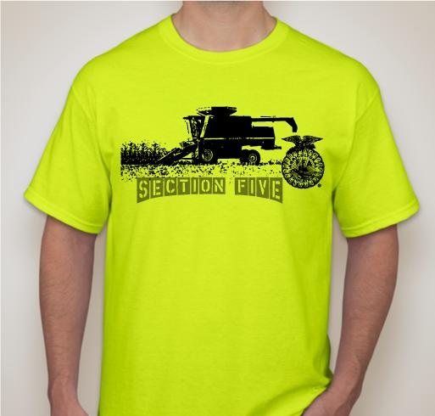

**December 3**

Agronomy CDE @ Metamora

**December 8**

State Agronomy@ University of Illinois

## Section 5 FFA…We stick to our Roots!

Thank you to all of the chapters that participated in selling the first round of T-shirts We will be doing a second round of T-shirt orders in December, so if you didn’t get one, but you would like one, you can place an order by December 31st to receive your Section 5 FFA Tee.

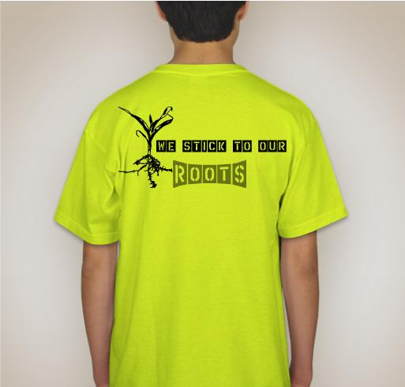

Send the money and order to Tessa Cowser by December 31st. Her address is:

**22707 W. Rt. 150**

**Elmwood, IL 61529**



The Section 5 Theme for the year: We stick to our roots!



Need ideas for Community Development? Help the Illinois Association FFA support our troops! We encourage chapters to collect items to send to the men and women serving our country overseas. Often times, it can be easy for us to take our freedom and rights for granted. By collecting supplies for our brave military, we can say thank you for their dedication and service to our country. After collecting the items, please bring them to the State Agronomy and Dairy Foods CDE at the University of Illinois on December 8th, 2012. If you are unable to attend that event please send all items to the Illinois FFA Center in Springfield. We will send all materials out from the center. If you would like to make a cash donation to assist in covering the postage expenses, that would be equally welcome. For a list of suggested items, visit the Illinois Association Website!  
  
Please help us support the brave men and women that left their homes and country to protect ours!

**ON**



**Chapter Visits**

The week of November 5-9th was Section 5 FFA’s chapter visits week. Dalton Heavner, the State Vice-President came up and stayed with us for a week while visiting all of the schools in Section 5. We visited all the schools in our section, encouraging them to be active in FFA and demonstrating good leadership. It was interesting to see all of the different schools and everyone learned a lot.

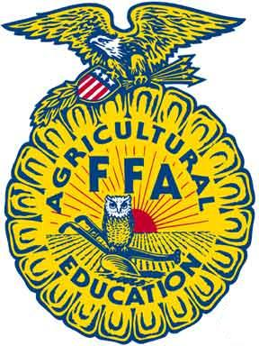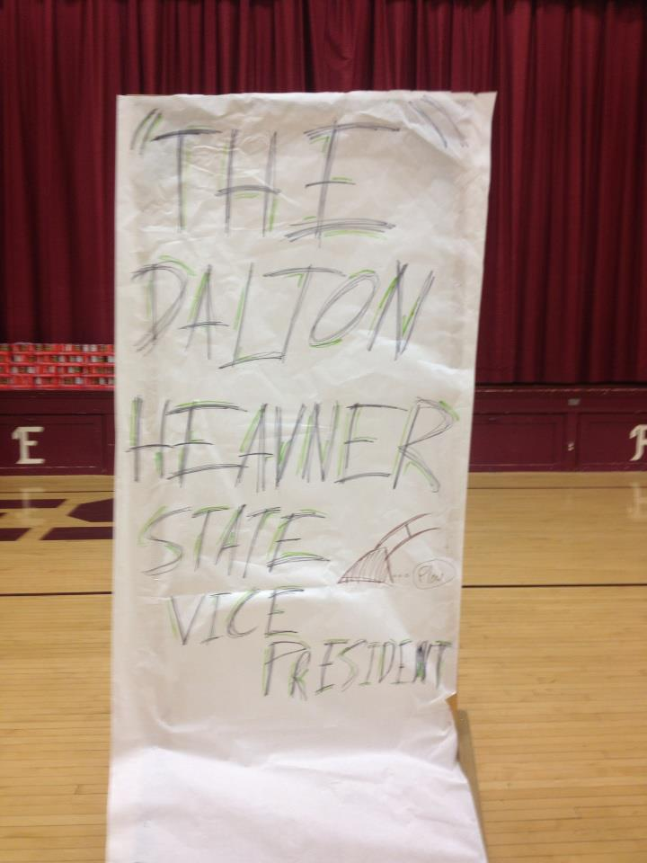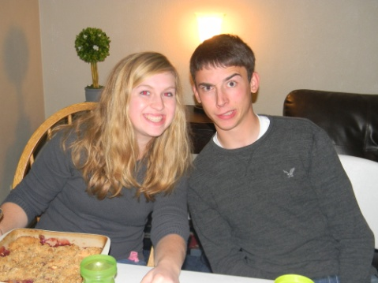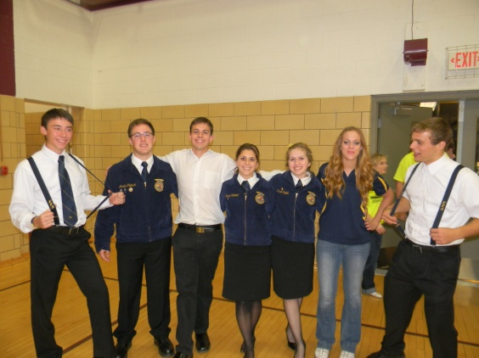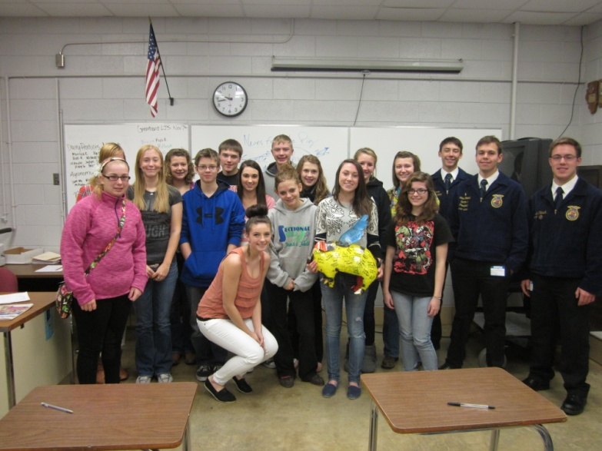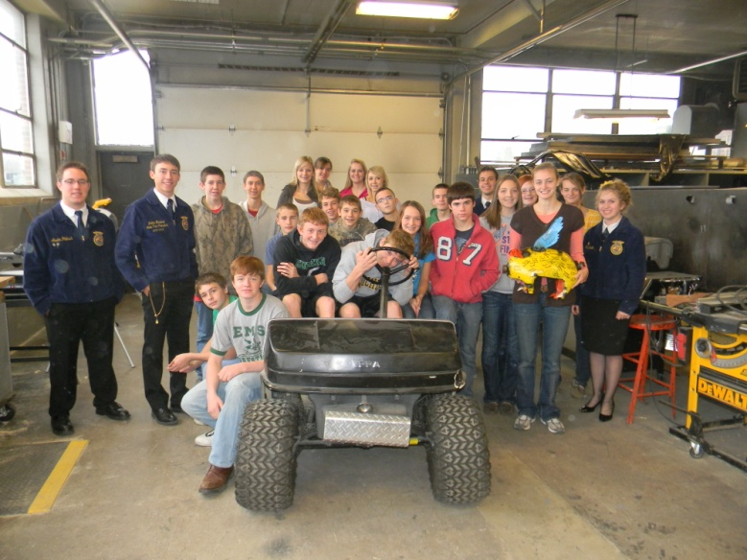

Dalton: We are really glad that you came to stay with us for a week and that we got to know you better! Thanks for serving Illinois FFA. We appreciate it!

Love, Section 5

Ethan, Austin, Mikaela, Aaron, Tessa, & Kristi

After listening to a week of him giving his Chapter Visits talk, I learned that Dalton Heavner is not interested in the poultry business. But I also learned that he is interested in following in the footsteps of his mother, and becoming an Ag teacher. And a teacher he is. A person can tell by listening to him speak that he has a natural teaching ability. Even when asking simple questions, he always makes sure to explain it thoroughly so that one can understand.

Throughout the week, we had the chance to get to know Dalton quite well, and we learned a lot about what he wants to do. Next year, Dalton is planning on going to Lincoln Land Community College and participating in the livestock judging team there. After that, he plans to go to Oklahoma State and major in Ag Education to become an Ag teacher.

Back home, Dalton comes from the Pittsfield FFA Chapter. While an FFA member in high school, Dalton was the chapter President, Vice President, and Treasurer. He then served on the section level as the Section 13 President and Historian. His SAE was on Beef Production and his favorite CDEs were Meats Judging and Ag Issues.

As the Chapter Visits week went on, all of the officers that went with Dalton got familiar with what he was going to talk about next and what he was going to say. But the one thing that we all said gave us chills was when he talked about the opportunities that the FFA organization offers. He used

the example of how he got the lowest grade on creed speaking his freshmen year, and his mom is his Ag teacher. But it didn’t stop there. The FFA gave him the chance to speak up and get over public speaking. And that’s what learning from a state officer is all about. It is seeing how the FFA changed their life, and how they want to give back to the members.

**Putnam County Ag Class**

**Metamora Ag Class**

## Learning from “THE” Dalton Heavner

##### Illinois Section 5 FFA

##### Traveling Trophy Update

The traveling trophy is currently in the hands of the **Midland FFA Chapter**. They won it at the Dairy Foods CDE. The next chance to win the prize is at the Agronomy CDE in Metamora on December 3rd. The chapter with the most number of times of having the trophy (the most 1st place wins at contests) will receive the trophy at the end of the year to display in their Ag classroom.

**ADDRESS:**

6823 W. St. Rt. 90

Princeville, IL 61559

**Phone:**

309.635.2496

**E-Mail:**

[mikaela.wieland@gmail.com](mailto:brw92@frontier.com)

**FACEBOOK PAGE:**

Illinois Section 5 FFA

**Ethan Wieland~ President**

* 3**0**9.219.6499
* rileyw2020@gmail.com

**Austin Pletsch~ Vice President**

* 815.488.2195
* austinpletsch@gmail.com

**Mikaela Wieland~ Reporter**

* 309.635.2496
* mikaela.wieland@gmail.com

**Aaron Herrmann~ Secretary**

* 309.635.7769
* herrmann.aaron@yahoo.com

**Tessa Cowser~ Treasurer**

* 309.645.3602
* tesscc13@yahoo.com

**Kristi Smith~ Sentinel**

* 309.645.7885
* kristilynnsmith530@gmail.com

## Chapter Reporters:

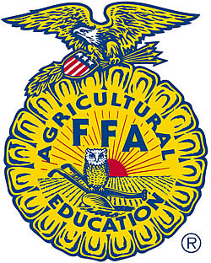

Chapter Reporters: I encourage you to send me your articles on what is happening in your chapter. I will make a page in this newsletter for the Chapter Chatter. This is basically a place for your chapters to submit their news and you can also see what other chapters are doing to get some ideas for your chapter. This will be a benefit for you to have a place to submit news. I will also place your articles on our webpage under the “Chapters” tab.

We’re on the Web!

*See us at:*

**ilsection5ffa.yolasite.com**

##### Subscription Information

If you know of anyone else who would like to subscribe to the Section 5 Blue & Gold Journal, please give them my email address, and I will start sending them their copy of the Blue & Gold Journal.

#### About Our Organization…

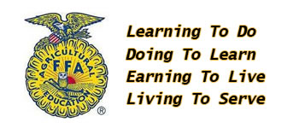

The National FFA Organization is dedicated to making a positive difference in the lives of students by developing their potential for premier leadership, personal growth and career success through agricultural education.