**November 2012**

**Volume 1, Issue 5**

Blue & Gold Journal

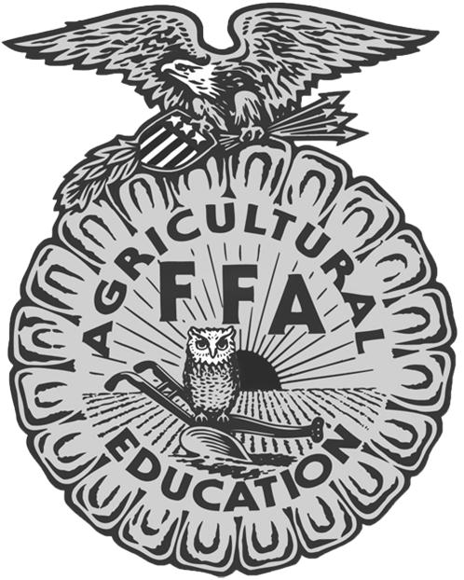

Mikaela Wieland

Section 5 Reporter

309.635.2496

mikaela.wieland@gmail.com

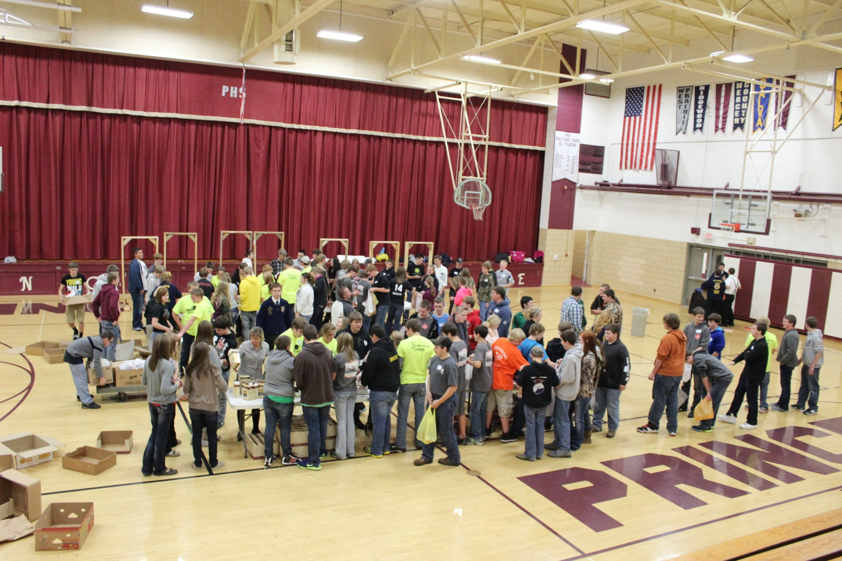

It’s hard to explain to someone. Wait, you’re ordering 120 pulled pork sandwiches for what? That’s right. It’s for Leadership Training School. It is designed to introduce new members to what FFA is all about and the opportunities they can have through FFA and to discover how they can become great leaders. We also use it as an opportunity for the section officers and chapter officers to meet and discuss the duties of their leadership positions. This year, Section 5 LTS was held on Wednesday November 7th at Princeville High School. Registration started at 4:30 and we kicked off the evening with an “unofficial” official dress demonstration. The section officers dressed up in their official dress, but wore it inappropriately, to demonstrate what NOT to wear. After the demonstration, we had an unforgettable opening ceremony! And since we were all hungry, we headed down to the cafeteria to enjoy those pulled pork sandwiches to get the evening off to a good start. Once everyone was satisfied, we all headed back up to the gym to help out those in need, whose food doesn’t come as easily. We wanted to help out this year at LTS and we packed food kits to take to those in need of food this holiday season. This showed everyone that helping others is a big part of FFA and being a good leader. After this, we split into groups of officers and Greenhand FFA members to learn some more about being a leader.

***Individual Highlights:***

Convention ……………2

Land Use CDE……...…3

Upcoming Events…….4

Discovering Passions..5

Contact Us………….....6

***Special Interest Articles:***

* Section 5 LTS
* Chapter Visits
* Getting to Know “The” Dalton Heavner

C:\Users\Brian\AppData\Local\Microsoft\Windows\Temporary Internet Files\Content.IE5\NVS9N8BE\MC900389884[1].wmf

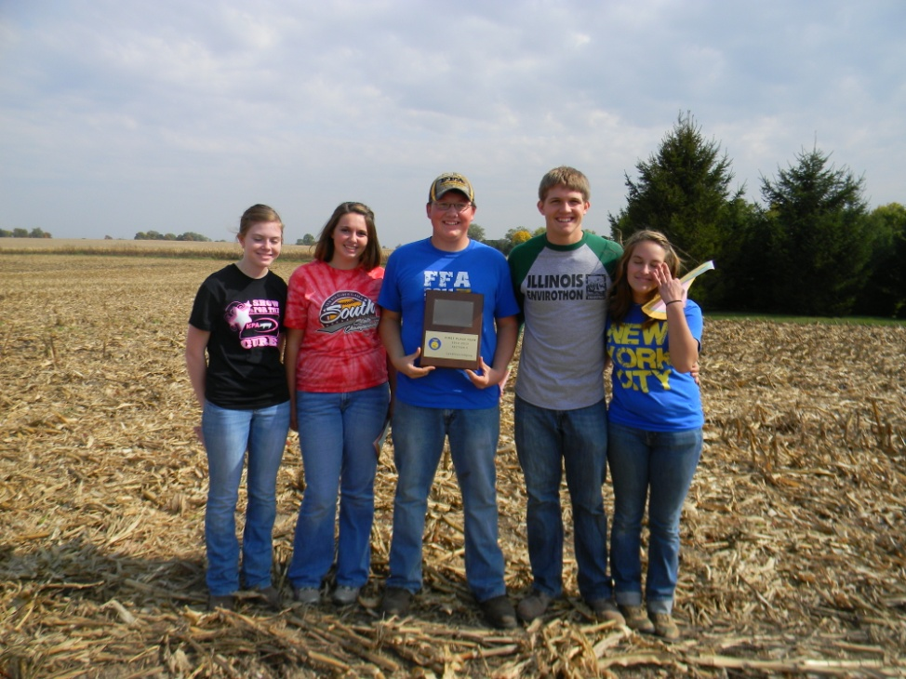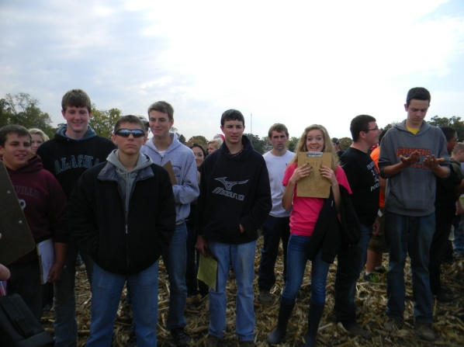

## Section Land Use CDE

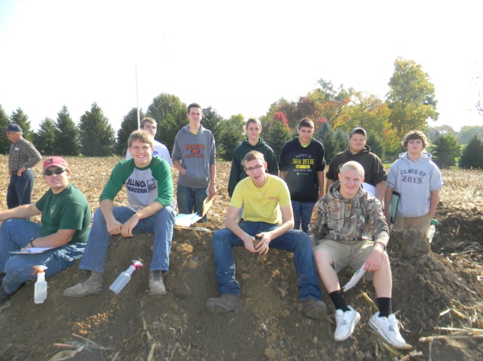

The Midland FFA Chapter with their 1st place trophy from Land Use.

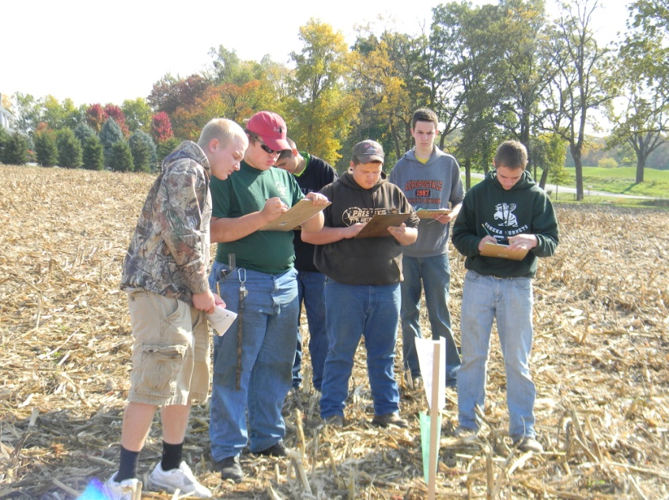

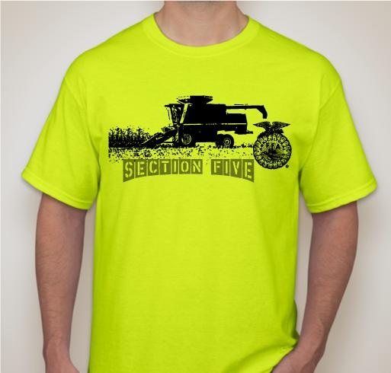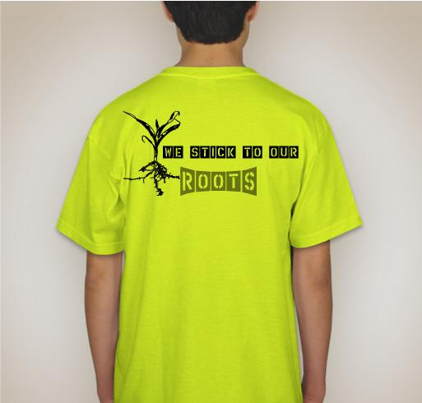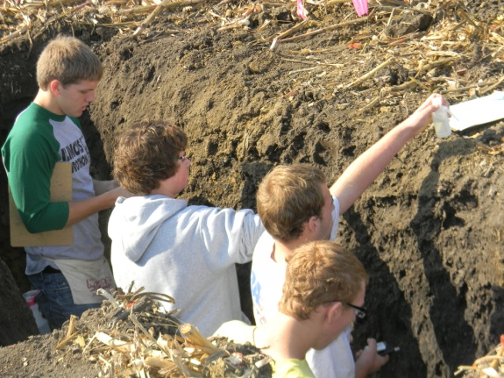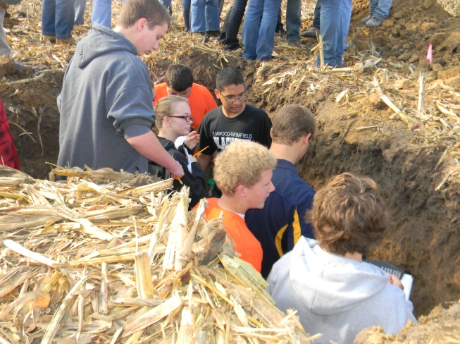

Due to screen printing and pricing, the t-shirt design is slightly modified from the original.Thanks for your cooperation!

Send the money and order to Tessa Cowser by December 31st. Her address is:

**22707 W. Rt. 150**

**Elmwood, IL 61529**

Thank you to all of the chapters that participated in selling the first round of T-shirts. We will be passing them out at the Leadership Training School in Princeville on November 7th. **The Morton FFA Chapter** had the highest percentage of T-shirts sold to their members and will be receiving some awesome FFA prizes for their chapter at LTS. We will be doing a second round of T-shirt orders in December, so if you didn’t get one, but you would like one, you can place an order by December 31st to receive your Section 5 FFA Tee.

## Section 5 FFA…We stick to our Roots!

The Section 5 Theme for the year: We stick to our roots!der’s attention, place an interesting sentence or quote from the story here.”

**December 3**

Agronomy CDE @ Metamora

**December 8**

State Agronomy@ University of Illinois

Products CDE



**ON**





Section 5 FFA…We Stick to our roots!

If you asked my mom about my role in the FFA, she would say I am plenty involved. In fact, most people tend to think I am overbearing sometimes. But to me, it’s just my personality and my passion. You see, when I am passionate about something, I go full force and stop at nothing. This gets things done, but I also happen to slack off on things like (ehemm) house chores (hence my mother saying I am PLENTY involved).

My passion for FFA really started at the end of my freshmen year. There are no words to describe exactly how I feel about FFA, and the only thing I can say is how much it has done for me. It has grown me as a person in so many ways, such as in leadership, responsibility, and integrity. I am just so grateful for everything that this organization has taught me that I can’t help but love it, the people in it, and want to have the chance to serve and give back to it. That is why I am your section reporter today. I am here to live out and share my passion for agriculture and FFA with others.

It is a really cool thing when you finally figure out what your God-given talents are and how you can use those to serve. Since I was young, I was always taught that God has a plan for my life and that I will figure it out when I am older. Now I’m older. Through FFA and my SAE’s, I have figured out what I am passionate about in agriculture and what I want to continue to do in life. Having an SAE on Ag Communications, I have discovered that I have been blessed with talents in this field and I absolutely love what I do. Because of this, it’s an easy choice to decide that in college I want to major in Ag Communications. I am still undecided on what college I will attend, but I look forward to pursuing a career in this field and seeing what other plans God has for my life. It is my pleasure and passion to serve as your 2012-2013 Section 5 Reporter!

## Discovering My Passions…

**I am so grateful for all the friends and memories that I have made through FFA experiences!**

Love In Blue & Gold, Mikaela Wieland

Section 5 Reporter

##### Illinois Section 5 FFA

##### Traveling Trophy Update

The traveling trophy is currently in the hands of the **Midland FFA Chapter**. They won it at the Section Land Use. The next chance to win the prize is at the Food Science CDE at Midland on November 1st. The chapter with the most number of times of having the trophy (the most 1st place wins at contests) will receive the trophy at the end of the year to display in their Ag classroom.

**ADDRESS:**

6823 W. St. Rt. 90

Princeville, IL 61559

**Phone:**

309.635.2496

**E-Mail:**

[mikaela.wieland@gmail.com](mailto:brw92@frontier.com)

**FACEBOOK PAGE:**

Illinois Section 5 FFA

**Ethan Wieland~ President**

* 3**0**9.219.6499
* rileyw2020@gmail.com

**Austin Pletsch~ Vice President**

* 815.488.2195
* austinpletsch@gmail.com

**Mikaela Wieland~ Reporter**

* 309.635.2496
* mikaela.wieland@gmail.com

**Aaron Herrmann~ Secretary**

* 309.635.7769
* herrmann.aaron@yahoo.com

**Tessa Cowser~ Treasurer**

* 309.645.3602
* tesscc13@yahoo.com

**Kristi Smith~ Sentinel**

* 309.645.7885
* kristilynnsmith530@gmail.com

## Chapter Reporters:

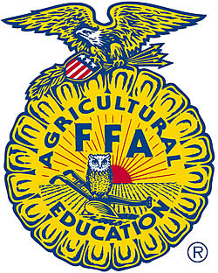

Chapter Reporters: I encourage you to send me your articles on what is happening in your chapter. I will make a page in this newsletter for the Chapter Chatter. This is basically a place for your chapters to submit their news and you can also see what other chapters are doing to get some ideas for your chapter. This will be a benefit for you to have a place to submit news. I will also place your articles on our webpage under the “Chapters” tab.

We’re on the Web!

*See us at:*

**ilsection5ffa.yolasite.com**

##### Subscription Information

If you know of anyone else who would like to subscribe to the Section 5 Blue & Gold Journal, please give them my email address, and I will start sending them their copy of the Blue & Gold Journal.

#### About Our Organization…

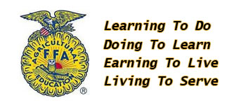

The National FFA Organization is dedicated to making a positive difference in the lives of students by developing their potential for premier leadership, personal growth and career success through agricultural education.